Chapter 17, Problem 25.

Determine the Fourier series representation of the function in Fig. 17.63.
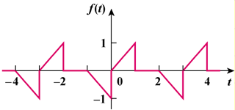

Figure 17.63
For Prob. 17.25.

